Ex.No:25: SIMULATION OF CONVOLUTIONAL CODES AND ANALYSIS OF ENCODED OUTPUT BIT SEQUENCES USING MATLAB
Objective 1:
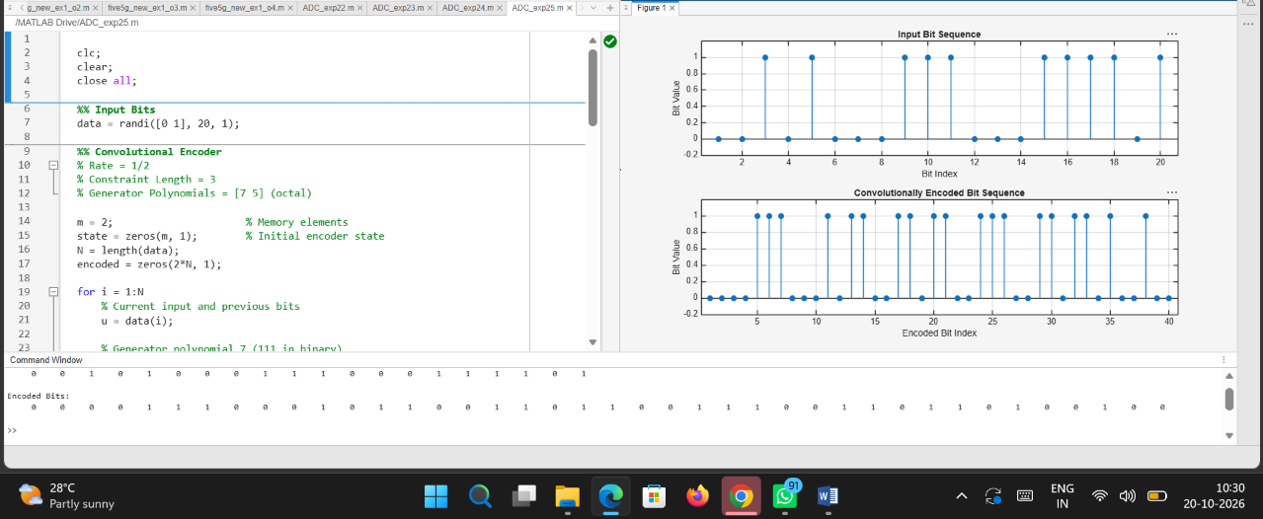
Code:

clc;
clear;
close all;

%% Input Bits
data = randi([0 1], 20, 1);

%% Convolutional Encoder
% Rate = 1/2
% Constraint Length = 3
% Generator Polynomials = [7 5] (octal)

m = 2; % Memory elements
state = zeros(m, 1); % Initial encoder state
N = length(data);
encoded = zeros(2*N, 1);

for i = 1:N
% Current input and previous bits
u = data(i);

% Generator polynomial 7 (111 in binary)
out1 = mod(u + state(1) + state(2), 2);

% Generator polynomial 5 (101 in binary)
out2 = mod(u + state(2), 2);

% Store encoded output bits
encoded(2*i-1) = out1;
encoded(2*i) = out2;

% Update encoder state
state(2) = state(1);
state(1) = u;
end

%% Display Results
disp('Input Bits:');
disp(data');

disp('Encoded Bits:');
disp(encoded');

%% Plot Results
figure;

subplot(2,1,1);
stem(1:N, data, 'filled');
title('Input Bit Sequence');
xlabel('Bit Index');
ylabel('Bit Value');
ylim([-0.2 1.2]);
grid on;

subplot(2,1,2);
stem(1:length(encoded), encoded, 'filled');
title('Convolutionally Encoded Bit Sequence');
xlabel('Encoded Bit Index');
ylabel('Bit Value');
ylim([-0.2 1.2]);
grid on;

Output:
